**Results for Question-2**

**Visualization-1 (Stacked Bar Chart)**

The below visualization shows the students who completed or did not complete the test preparation, grouped by their race and lunch type.

Through this it is also easier to compare the test preparation with different race groups.  
Also, easy to examine the involvement of lunch type between the race and the test preparation.

**Visualization-2 (Bar Graph)**

From the below visualization it is easy to identify the performance of females in reading scores are much better than the males.

**Visualization-3 (Box Plot)**

From the below visualization, it is easier to compare the scores between the students who completed the test preparation and those who didn’t.

Also, we can easily identify the impact on the performance of different subjects based on test preparation.

**Visualization-4 (Star Plot)**

From the below visualization, it will be easier to compare the performance of students in each subject based on the level of their parent’s education.

Also, from this visualization based on the given data, we can observe that students got better scores whose parents have higher education.

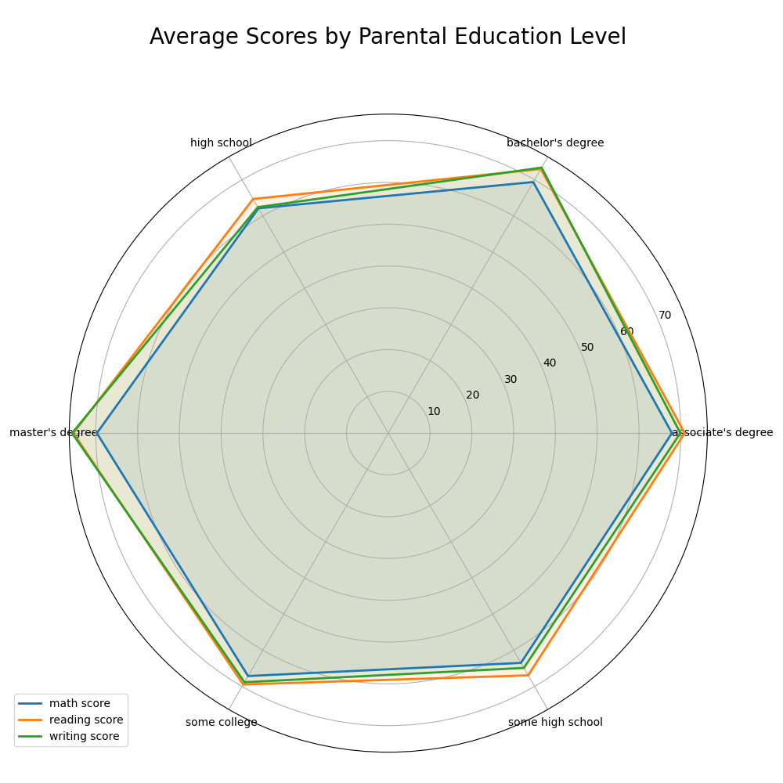

**Visualization-5 (Line Plot)**

From the below visualization it is easy to identify, the number of students from different race or groups, who opted for each lunch type.

Also, from this visualization it is easy to identify that, number of students in ‘group-A’ is lesser comparatively to all the groups, and there are higher number of students in ‘group-c’ compared to all groups.

